Annual Report for 2018 January 2019

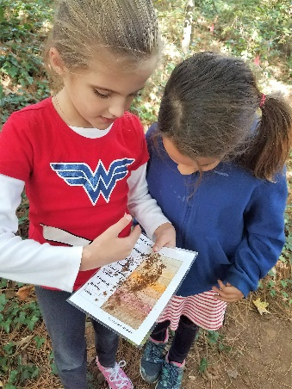 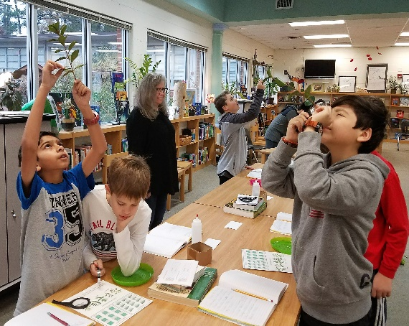A letter from the Chair:
On behalf of the Oak Grove Foundation, I want to thank you for your contributions to the Foundation and Oak Grove Elementary in 2018. We were thrilled to have obtained STEM certification for the entire school this past spring through the hard work of the School’s faculty, staff, parents and the Foundation! Your contributions have given the dedicated staff the resources they need to provide our children with the best possible learning experience.

As Principal Mauborgne says, "Every dollar given to the Foundation has an impact on children." We want to share with you some of the ways your generous contributions have supported our children's education this year:
- New computers and a 3D printer
- New furniture for the STEM room
- Funding for our fantastic literacy coach and STEM coordinator
- Grants for teachers to bring innovative programs to the classroom
- Additional training for our dedicated teachers
- Incentives to reward and retain top teachers
- Educational consultants to implement certified programs

Rather than talking about “gifts” or “donations” to the Foundation in coming years, I suggest we talk about “investments.” When you write a check to support the Foundation or purchase something at the Campaign Kickoff Party and Auction, you are investing in your child(ren) and our special community.

Finally, 2019 marks the ten year anniversary of the Foundation! Oak Grove Elementary would not be the place that it is today if not for the investments of our families and neighbors over the past decade. Let’s ensure this community remains strong for decades to come!

Amity Farrar
2018-2019 Oak Grove Elementary Foundation Chair
In this report
- From the Chair
- Accomplishments
- Board Members
- From the Principal
- Financials
- Investors
18
Oak Grove Foundation was created in 2009 as a non-profit (501(c)(3) formed by parents and teachers that supports the quality of education at OGE through investments in teachers, technology and materials -- funded entirely through YOUR donations!

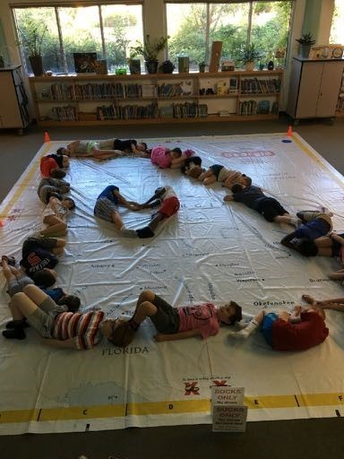

2018/2019 Board of Directors

Chairs
Amity Farrar & Molly Taggart Treasurer
Carol Smith & Hilary Bailey Secretary
Katie Eaton
Annual Campaign Chairs Priscilla Janowski & Liz Shallenberger
Big Ideas Chair
Jennifer Hill
Higher Opportunities for Teachers Chair
Beth Vertino Website
Michelle Walsh
Members
Lynda Mauborgne (Principal), Julie Bemiss, Rebecca Brown (Teacher), Kristi Gage, Lauren Garbade (Teacher), Beth Haynes, Radha Kelly, Lindsey Luepke, Tracey Maloney, Rakhi Narwani, Kristen Schafer, Lisi Winter, Kendall Xides

2018 Accomplishments

With your generous support, the Oak Grove Foundation
provided funding to supplement:
Teachers’ Education I Academic Enrichment I Classroom Excellence

STEM Coordinator (Science, Technology, Engineering, and Math).
STEM Coordinator Kendall Xides implemented programs and teacher training for our STEM program. Mr. McCarthy and Ms. Xides’ efforts helped the School achieve AdvancED STEM certification in Spring 2018 – a significant accomplishment!

Literacy Coach. Literacy Coach Stacy Welch worked with K-2nd grade students to assist them with reading skills.

STEM. The Foundation funded supplies for our ongoing STEM program. A few examples:
- STEM Books
- Special STEM-themed Days
- Almost $10k worth of technology
- Lego Night
- Atlanta History Center trunk rental

Higher Opportunities for Teachers (“HOT”). The Foundation funded tuition costs for teachers and staﬀ from all grade levels to attend several conferences and courses including:
- Summer STEM Institute for ALL OGE teachers!
- Math training for 4th grade teachers
- Health and physical fitness training for Coaches Anberg and Owen

Big Ideas Grants. The Foundation awarded several grants for teachers for enrichment activities in the
classroom including:
- Newspaper subscription for special education classrooms
- Kindergarten teaching software

Leadership Stipends. The Foundation provided over $10,000 in incentives to reward and retain our amazing teachers who serve on the Building Leadership Team, STEM team, and as grade level chairs.

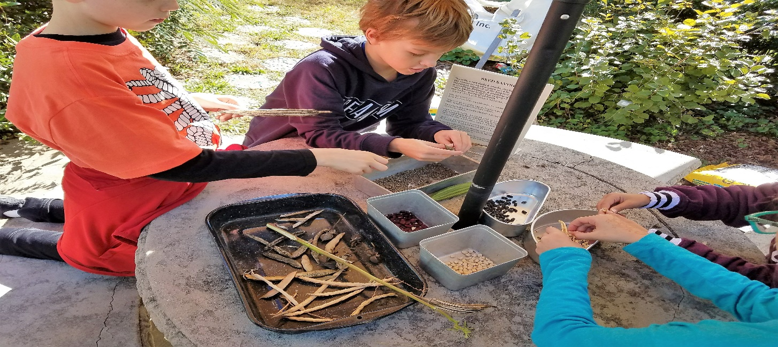

A letter from our Principal:

As we approach the “Opening Day” of the Annual Campaign for Education for Oak Grove’s Foundation, I am excited to share the many ways the Foundation has touched every student in the building. The list continues to grow as people continue to give. Thank you for providing so generously for all students. As you invest in them, you are shaping the future.

Your gift to the Foundation provides grants for teachers to attend conferences and other continuing education opportunities. Staff members use the information and skills they learn to help students learn in different ways.

Another direct impact of the Foundation is closing reading gaps is through a part-time literacy coach. Mrs. Stacy Welch’s work with small groups of students in Kindergarten through 2nd grade continues to be successful, and the Foundation has agreed to renew her contract another year! Students not receiving direct assistance from Mrs. Welch benefit from the smaller class size and more time with the teacher while other students are working with Mrs. Welch. It’s a “Win-Win” for all!

Since receiving the AdvancED STEM certification in May 2018, the Foundation continues to provide support for the growth and sustainability of the STEM initiative. The Foundation will also continue to support STEM/STEAM through the part-time coordinator, Mrs. Kendall Xides. Mrs. Xides continues to plan STEM-focused activities for the entire school and provides support to the staff directly and through the STEM committee. Mrs. Xides can often be found providing meaningful enrichment in the garden and/or writing fun facts on the board to increase background knowledge. She has a gift for stimulating interest in science and technology, even in reluctant learners. Mrs. Xides continues to work collaboratively with teachers as we seek research-based, real life resources to provide meaningful experiences for children.

Obtaining STEM certification was the first step. Now we are required to show growth within the program in order to keep our certification. The Foundation supports the sustainability of our STEM program through the Summer STEM Institute (“SSI”) for teachers. Planning meaningful project-based learning opportunities and experiences takes time and collaboration, and the SSI provides this opportunity.

It is my goal to ensure every student has access to technology. It is critical students have experience with both Apple and MicroSoft platforms so they can thrive in a digital society. Last year, through your generosity, the Foundation purchased six Macs and a 3-D printer for student use. While devices are not intended to replace great teachers, teachers use technology to enhance the overall learning, as well as teach the research and design processes. It is my goal to have six more Macs added this year to give students the support they need to do creative design for STEM/STEAM projects. Your generous gift can help make this dream a reality.

If there is a surplus in this year’s campaign, we would love to hire a part-time math coach to provide support to grades 3 – 5 to close gaps in learning. This person would function in a similar way to the literacy coach, providing math instruction for those who need additional help, which benefits all students.

The Foundation does so much to support and enrich the instructional program at Oak Grove by sending teachers to conferences, funding staff positions, purchasing resources, and providing technology for all students. Every dollar given to the Foundation has an impact on children. The Foundation touches EVERY child at Oak Grove! I sincerely appreciate the instructional support provided by the Foundation, funded by your generosity. Thank you for investing in our children and community.

Sincerely,

Lynda Mauborgne
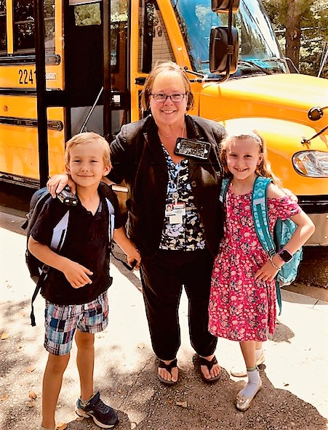

5th Grade Frog Dissection
Sponsored by the Oak Grove Foundation
2018
Financials

Income
Direct Public Support
Total 2018 Spring Campaign Donations
$106,146.03
Total Corporate Donations
$11,097.72
Total 2019 Advance Campaign Donations
$500.00
Investments
Total Interest-Savings, Short-term CD
$232.29
Other Types of Income
Total Amazon.com Revenue
$2,014.06
Total Income
$119,990.10
Net Income
-$6,254.50
Expense
Awards and Grants
Total STEM Seeds Wish List-Classroom Enrichment
$5,118.33
Total Big Ideas - Classroom Enrichment
$6,965.38
Total Higher Opportunity for Teachers - Training
$19,536.47
Total Leadership Stipend
$11,100.00
Total STEM Supplies
$4,192.06
Total Awards and Grants
$56,624.77
Contract Services
Total Literacy Coach
$28,600.00
Total STEM Coordinator
$26,235.00
Total Contract Services
$54,835.00
Fundraising
Spring Campaign 2018
Total Events – Food, Venue
$8,331.02
Total Incentive Events / Prizes
$1,890.33
Total Printing / Publicity
$591.28
Total Computer Technology

Operating Expenses
Total Accounting Supplies
$597.80
Total Bank/PayPal Fees
$2,043.48
Total Insurance Premium
$255.00
Total Postage, Mailing Service
$64.20
Total Printing and Copying
$72.92
Total Website
$215.91
Total Fundraising
$11,213.53
Total Operating Expenses
$3,571.30
Total Expense
$126,244.60
Total Board Supplies
$321.99
Spring Campaign 2019
Total Advance Printing / Publicity / Prizes
$400.90
December 31, 2018 Closing Bank Account Balance
$113,270.57
$9,712.53

SHOW YOUR LOVE 2018

Diamond Investors $2500+
Anu Ghosh & Farzan Bharucha
Rachel & Sam Burst
Mandy & Ryan Ford
Priscilla & Jayson Janowski
Tracie & Adam Maloney
Amy & Jonathan Merrill
Kavitha Gopal & Sridhar Ramalingam

Platinum $1000-$2499

Alia & Julian Brown
Danielle & Jon Chizzolin
Karen & Chris Durden
Katie & Jonathan Eaton
Elizabeth & Neil Edgerton
H.Hendricks Edgerton
Amity & Derik Farrar
Susie & Brian Findley
Beth & John Haynes
Jacqueline Hill
Radha & Adam Kelley
Christie & Michael Lo
Monruedee & Christopher
Mapes
L. Philips Martin
Molly & Mike McAuliffe
Tiana & Jeff Mykkeltvedt
Hyung Mi & Jae Nam
Rakhi & Nik Narwani
Camille & Raul Nogueira
Chhaya & Amit Patel
Betsy & David Preiss
Alyson & Niels Richardson
Clare & Daniel Roath
Angela & Dusty Schaffner
Erin & Stephen Speigal
Sri Edupganti & Gautam Sreeram
Anna & David Von
Eleanor Ho & Alan Wang
Allison & Brad Webb

Ruby $500-$999

Maria Arraiza & Nicolas Bianchi
Sarah & Wes Brewer
Cassy Quave & Marco Caputo
Echia & John Chihade
Sushma & Blaine Cribbs
Erin & Scott Davis
Shruti & Ajeet Dhingra
Julie Etzel & Jeremy Dobbie
Marilen & Hamlin Endicott
Erin & Aaron Hurst
Holly & Tommy Hidell
Allison & Jimmy Houston
Genie & Brent Iredale
Heather Julien
Tracy & Rob Kanaczet
Joan Kaplan
Irina & Todd Knudsen
Katrina & Matthew Kramer
Bibi & Darren LeVine
Heather & Jonathan Lively
Sherly Hall & Michael Markos
Amie Meschi
Lisa Tadayon & Frederic
Rahbari Oskoui
Katie & Clay Pinckard
Morgan & Cary Potts
Lucinda & TJ Sellers
Liz & Jay Shallenberger
Robyn & Jeff Sjogren
Carol & Michael Smith
Camille & Michael Vaughan
Beth & Albert Vertino
Neisha & Brian Wagner
Michele & Jack Walsh
Susan & Steven Yeh

Gold $250-$499

Taiye & Yemi Adekunle
Shannon Robinson & Nabil Ahmed
Renita & Rob Anderson
Mirna & James Andrews
Hilary & Pat Bailey
Loren & Shane Bartlett
Madhuri & Sridhar Basavaraju
Pinar Keskinocak & Bulent Basaran
Ashlee & Chris Bennett
Robyn & Todd Bethany
Jean & Team Black
Laura & Todd Bolsen
Stephanie & David Braatz
Ashley Bryant
Melinda Burke-Budhram & Kris Budhram
Julianne Coleman
Marieli & Loren Colon
Lisa & John Cowden
Laura Hewett & Brad Curran
Carrie Edwards & Jason Daffner
Ewa & Michael Dattilo
Kelli & Wade Davis
Mariam & Alpha Diallo
Amber Hurlburt & Matt Dickason
Chanju Lee & Dongwook Lim
Trudi & Keith Ellerman
Juan Flores
Lisa & Dave Foreman
Kristi & Aaron Gage
Abhi & Arvinda Goel
Runa & Sumeet Gokhale
Katie & Chris Green
Evelin & Santiago Grijalva
Sara & Mike Gurion
Amy & Jay Hanson, Sr.
Jennifer & Keshawn Harry
Heather & Mike Henry
Jennifer & Owen Hill
Diane Hoang
Sonia & Jon Hoey
Aimee & William Hu
Olga Shemyakina & Hari Iyer
Stephanie & Andy Kazama
Lauren & Matt Kehrli
Teresa & Wynn Keith
Namita & Dhruv Khanna
Olivia & Sterling Krick
Jean & Binu Kunjummen
Deborah & Howard Kuo
Hye & YS Lee
Cathy & Brandi Lesesne
Sheri & Michael Lignos
Ying Zhou & Yang Liu
Lindsey & Reid Luepke
Nadine Roryshul & Youssef
Maakaroun
Kristi Richardson & Mark McEnaney
Jody & Rob McHoul
Laurie & Brian McNamara
Hollie & Vince Meglio
Emily & Grant Mogan
Neha Shah & Anupam Narula
Claudia & Michael Ojalvo
Anne & Soeren Olesen
Kofo & Taofeek Owonikoko
Eileen Byrnes & Tommy Parks
Priti Patel
Paige Payne
Crissie & Bobby Perez
Jennifer & Jeff Peters
Kristen Picano & Craig Pohan
Kimberly & Aristotle Rabanal
Kristin & Gabriel Rainisch
Sheila & George Rauch
Jez DeWolff & Doug Richards
Allison & AJ Rollins
Tobey & Mathew Sapiano
The Sarihan Family
Ashley Rush & Nathan Scronce
Sheetal & Manan Shah
Tina Bhavsar & Sanket Shah
Tara & Robert Sidonio
Jackie & Andy Smith
Keisha & Jimson Smith
Donna & Eric Snyder
Yingxin Wu & Le Song
Corette & Grant Stephens
Kristin & Patrick Sullivan
Molly & Tom Taggart
Veronica & Miiguel Thimann
Roshan George & Sherine Thomas
Karen & Octavio Valdivia
Eva & Eric Van De Water
Kim & Rod Vardeman
Sarah & Brian Visel
Angela & Jonathan Wells
Bryna & Carson Wiggins
Markie & Tim Wilson
Pamela & Bill Winterberg
Keith & Mary Tipton Woolley
Hong Yang

Silver $100-$249

Paula & Craig Ackerman
Anita & Jack Adair
Kara & Ryan Adams
Rama Tamimi & Bahaaldin Alsoufi
Liraz & Mike Beldie
Julie & Phil Bemiss
Morris Benveniste
Megan & John Bielema
Trang Nguyen & Geoffrey Bui
Jennifer Burns
Caterina & John Cappellari
Daisy Carroll
Asmita Singh & Deepak Chaturvedi
Lydia & Roy Clarkson
Nicole & Ryan Collins
Valerie & Chuck Cook
Augusta Cook
Mary & Collin Cook
Sophie Lukashok & James Cope
Sandra Coulsen
Catherine Huang & Don Durfee
Parham Eshtehardi
Nilah George
Lisette & Gregory George
Suzanne & Yoram Gilboa
Jesica Gourdet-Murray
Laurie Braswell & Stuart Graetz
Nitika & Apurve Gupta
Valerie & Steve Harrison
Bethany & Keith Hadelman
Jill & Ben Hafeli
Adriana & Jeff Hageman
Kate & Jeff Jay
Kristen Ulven & Daniel McKeithen
Mary Keller
Meredith & Bryan Kemp
The Kho Family
Mikyoung Kim
Tricia & Bruce King
Emily Hogue & Mike Krause
Sarah Fonder-Kristy & Nate Kristy
Jennifer & Steven LeClercq
Amy & Louis Lettes
Kathleen & Kenneth Lippe
Tolulope & John Louis-Ugbo
Jade & Keke Lyles
Laura & Adam Marcus
Ansley & John Martin
Jennifer Knupp & Kevin Maxey
Stella & Joshua Mayes
Harry McComb
Kevin McHam
Mike Meschi
Holly Wilson & Jeremy Miller
Myoungmo An & Sanggyu Min
Anne & Kevin Moore
Kechia & Curt Morrow
The Moxley Family
Kristi & Chip Mullins
Rimma Rubin & Ilya
Nemenman
Erin & Greg Newman
The Nguyen Family
Megan Poonolly & Sunil Nicholas
Francine & Ronald O'Neal
Holly & Eric Ortlund
Mary & Kevin Overcash
Kim & Ron Parsons
Lynn Patterson
Kathryn Colegrove & Maurice Ralston
Jennifer & Kevin Roche
Katy & Eric Rogers
Sanhita Bannerjee &
Pradipta Saha
Rachel & Chris Samuda
Kristin & Matt Schillig
Leslie Schulgen
Ronit Hoffer & Matthew Schwartz
Kristen & Andy Shafer
Melissa & Sanjay Sharma
Asmat & Fuad Siddiqui
Aysha Siddiqui
Rebecca & Eric Sigmon
Aimee & Jack Small
Howard Smith
Kristin & Parker Smith
Ephi Betan & Brian Snook
Kris & Jayson Stephens
Brent Sturgis
Phyllis & Andy Thomson
Liezel & Mark Thompson
Meli & Ben Thrower
Phyllis & Frank Tong
Katie & Matt Torres
Susan & Carl Valentino
Naya Vela
Sonya & Mark Verrill
Frederick Visel
Arline Walker
Molly & Kevin Wack
Xhenping Wang
Angelika Jagiello & Robert
Wieczynski
Jone Wiggins
Laurensia Wijaya
Sue Ellen Williams
Lisi & Bill Winter
Selena & Craig Zeff

OGE Supporter $1-$99

Kruti & Ryan Bolick
Lori & Shaun Brown
Meredith Carithers
Marlene & David Carnes
Marisa & Todd Clarkson
Erin DiChiara & Mike Coddington
Holly & Clinton Cole
Debra Collins
Branden & Hamilton Craig
Jennifer Cromey
Beth & Paul Deery
Michael Deming, Jr.
Chartan DeSelles
Janis Doering
Sharon & Chris Doering
Melody & Dusty Dunn
Sandra Echols
Ashley Etheridge
Maria Pappas & Ron Feldman
Rory & Dietre French
Sherri & John Forsythe
Jen Frenzel
Katherine Grube
Steven Grube
Lupita Ponce & Angel Herrera Guerra
Heather & Daks Hamner
Shivkumar Hatti
John Haynie
Shannon & William Higgins
Mandie & Brian Holmes
Fairleigh & Jay Hoots
Jennifer & Brian Hutcheson
Jeanne Kendall
Mehwish & Mohammad Khan
Jenai Lee
Stacey & Ryan Lucas
Noel Mainland
Trisha Kesar & Rahul Marwaha
April & Shaun McCarthy
Betty Meek
Cashmere & Denmeasecio Miller
Ivey Jowers-Milton
Michelle Dupont & Brian Mitchell
Faith & David Nash
Chris & Dimitri Papadimitriou
Samantha & James Parks
Mary Rose
Shital & Amit Shah
Maria & Gunter Sharp
Kacie & Matt Shumaker
Ann Chahroudi & Guido Silvestri
Jawauna Smith
The Solomon Family
Lauren & Josh Taylor
The Thomas Family
Lena Tomlin
Susan & Rutland Walker
Amanda Webb
Louise & Neale Weitzmann
Joanna West
Patty & Vance Wilder
The Woods Family
Liesl & Bill Wuest
The Yusufji Family
Kruti & Ryan Bolick
Lori & Shaun Brown
Meredith Carithers
Marlene & David Carnes
Marisa & Todd Clarkson
Erin DiChiara & Mike Coddington
Holly & Clinton Cole
Debra Collins
Branden & Hamilton Craig
Jennifer Cromey
Beth & Paul Deery
Michael Deming, Jr.
Chartan DeSelles
Janis Doering
Sharon & Chris Doering
Melody & Dusty Dunn
Sandra Echols
Ashley Etheridge
Maria Pappas & Ron Feldman
Rory & Dietre Ffrench
Sherri & John Forsythe
Jen Frenzel
Katherine Grube
Steven Grube
Lupita Ponce & Angel Herrera Guerra
Heather & Daks Hamner
Shivkumar Hatti
John Haynie
Shannon & William Higgins
Mandie & Brian Holmes
Fairleigh & Jay Hoots
Jennifer & Brian Hutcheson
Jeanne Kendall
Mehwish & Mohammad Khan
Jenai Lee
Stacey & Ryan Lucas
Noel Mainland
Trisha Kesar & Rahul Marwaha
April & Shaun McCarthy
Betty Meek
Cashmere & Denmeasecio Miller

Corporate Diamond $2500+
Audi Atlanta
Chick-fil-A North Druid
Dennis Dean Catering
KW Turtle Group

Corporate Platinum $1000+

Clinebell Orthodontics

Patel Development
Taiyo Ramen
Troutman Sanders

Corporate Ruby $500-999
Barron’s Fine Jewelry
Eaton Pediatric Dentistry
Fellini’s Pizza
Goodyear Tires
Intown ACE Hardware
Mathnasium of Tucker
Oak Grove Pet Sitting
Pinckard & Morgan Cleaners
Sweet Sky Photograpy

Corporate Gold $250-499
2be Photography
Echoplex Studio
Masquerade, Inc.
Nothing Bundt Cakes Tucker
Sherwood Chiropractic
Winterberg Advisory Group L

Corporate Silver $100-$249
Bambinelli's Pizza
Canvas Etc.
Clairmont Animal Hospital
Kid Chess
Kroger
Orange Theory
Publix
Toco Instant Printing
Top Nails Corporation
Workout Anytime
Zoo Atlanta
Corporate Supporters $1-$99
ACE Handy Hardware
Atlanta School of Gymnastics
Atlanta Botanical Gardens
Buckhead Yard Signs
Center for Puppetry Arts
CNN Tour
Kitchen Six
Napoleon’s Grill
Oak Grove Market
Rocky’s Auto Spa
Salon Phal
Shorty’s Wood Fired Pizza
Spicy Peach
Sprig
Susan Bee Goods, LLC
TADA
Target
Taziki’s Mediterranean Café
The Grove
Victory International Trading LLC

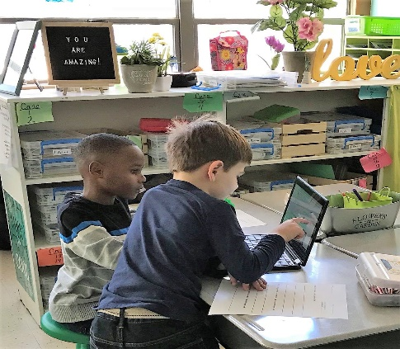

Thank you, again, for INVESTING in Oak Grove Elementary and our community in 2018!

